**Project Design Phase-II**

**Data Flow Diagram & User Stories**

|  |  |
| --- | --- |
| Date | 17-10-2022 |
| Team ID | PNT2022TMID13848 |
| Project Name | Personal Expense Tracker |
| Maximum Marks | 4 Marks |

**Data Flow Diagrams:**

A Data Flow Diagram (DFD) is a traditional visual representation of the information flows within a system. A neat and clear DFD can depict the right amount of the system requirement graphically. It shows how data enters and leaves the system, what changes the information, and where data is stored.

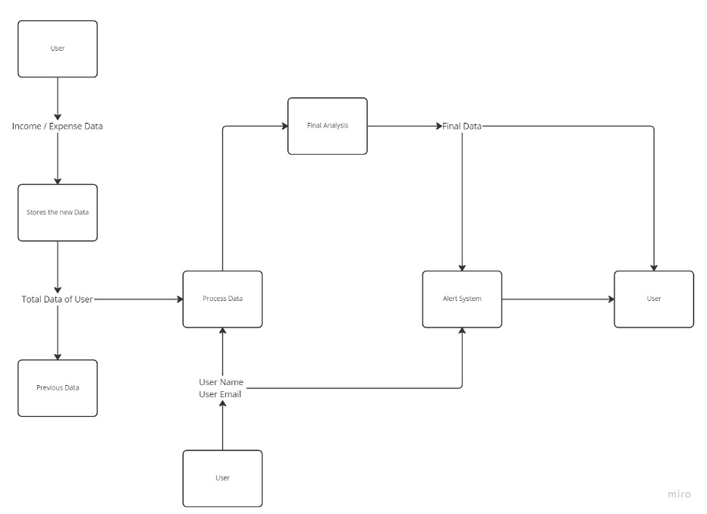

**User Stories**

Use the below template to list all the user stories for the product.

| **User Type** | **Functional Requirement (Epic)** | **User Story Number** | **User Story / Task** | **Acceptance criteria** | **Priority** |
| --- | --- | --- | --- | --- | --- |
| Customer (Mobile user) | Registration | USN-1 | As a user, I can register for the application by entering my email, password, and confirming my password. | I can access my account / dashboard | High |
|  |  | USN-2 | As a user, I will receive confirmation email once I have registered for the application | I can receive confirmation email & click confirm | Medium |
|  | Login | USN-3 | As a user, I can log into the application by entering email & password | I can access the application | High |
|  | Dashboard | USN-4 | As a user I can enter my expense, income and budget details | View my daily Expenses | High |
| Customer (Web user) | Alert message | USN-5 | As the user if you exceed the budget the user should get the alert message | I get the Alert Message | High |
| Customer Care Executive | Support | USN-6 | As a customer care executive, I can solve the log in issues and other issues of the application. | I can provide 24/7 solution support | Medium |